Creating Lists of Everything in Your Library:

1) Along the top, click Reporting. Then click Listes-exemplaires

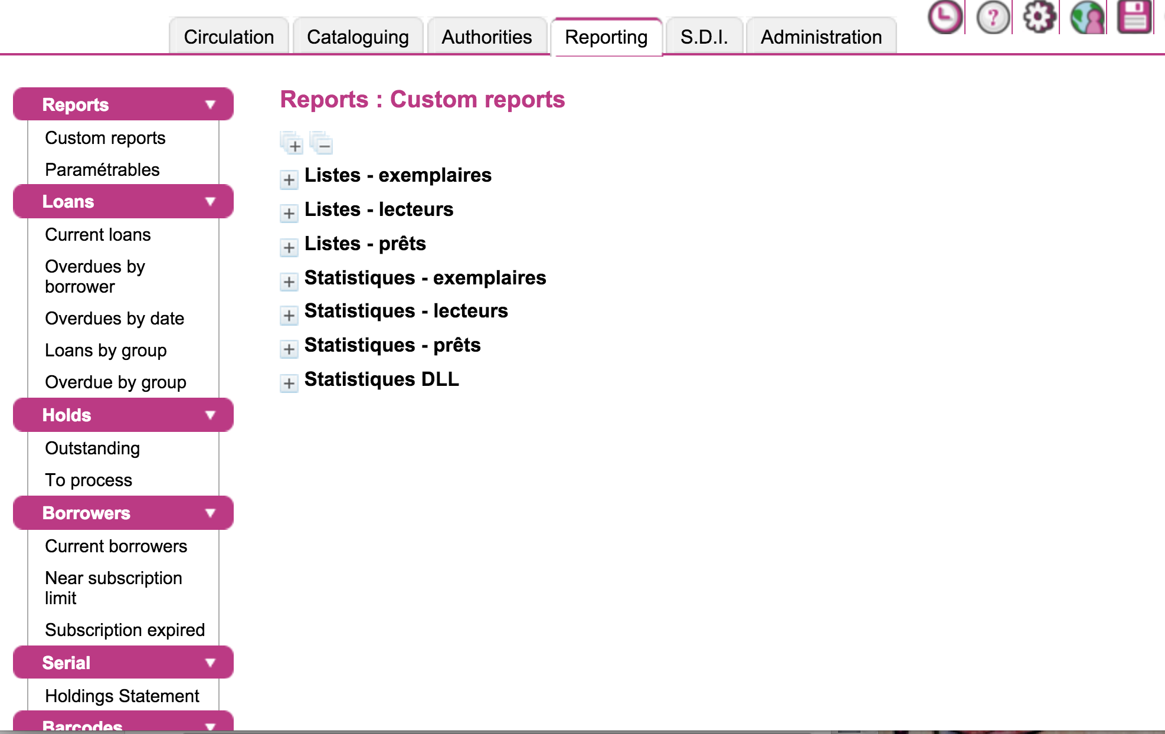

2) Under Liste-exemplaires, choose what type of report you want to do. I find “Liste de exemplaires d’un propriétaire par statut/localisation/section” to be the most helpful list.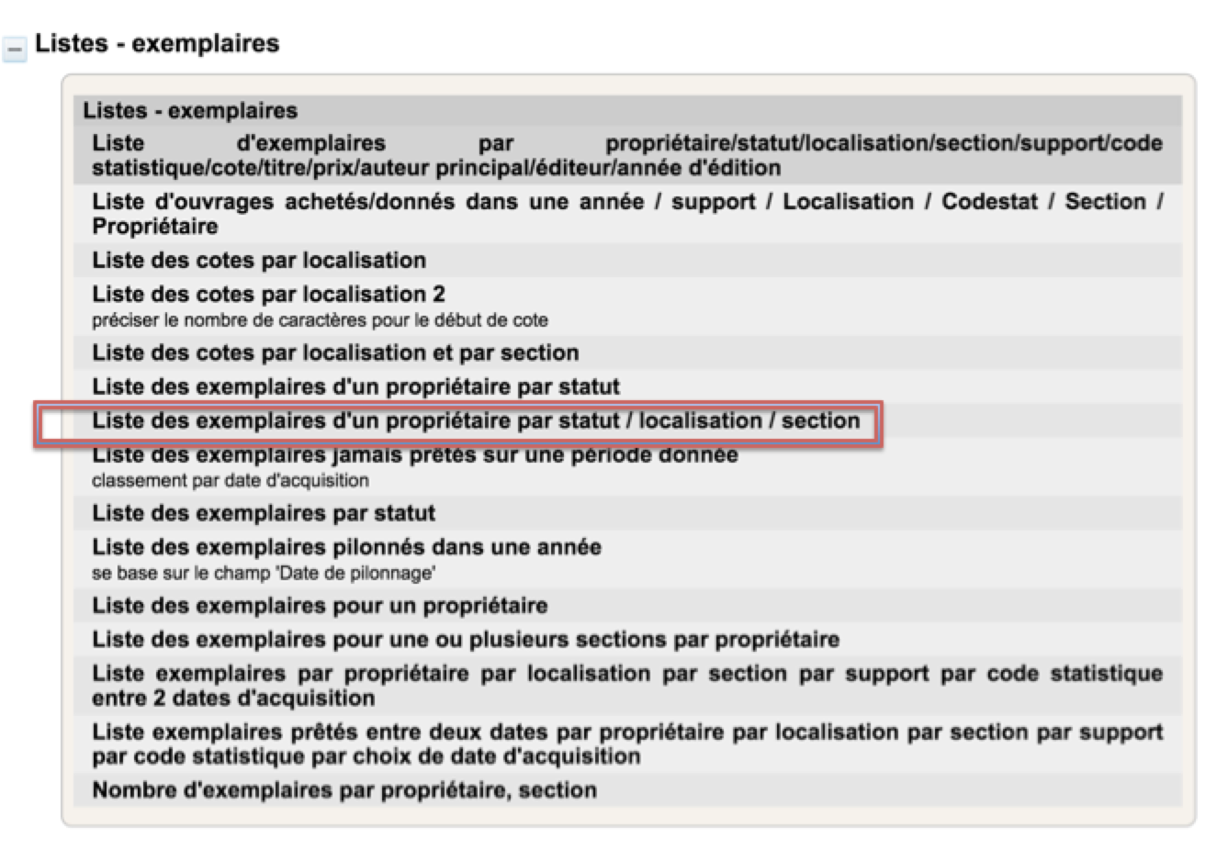

3) Fill out the info for your library (if you want all the sections, hold the shift key while clicking the first and last book on the list)

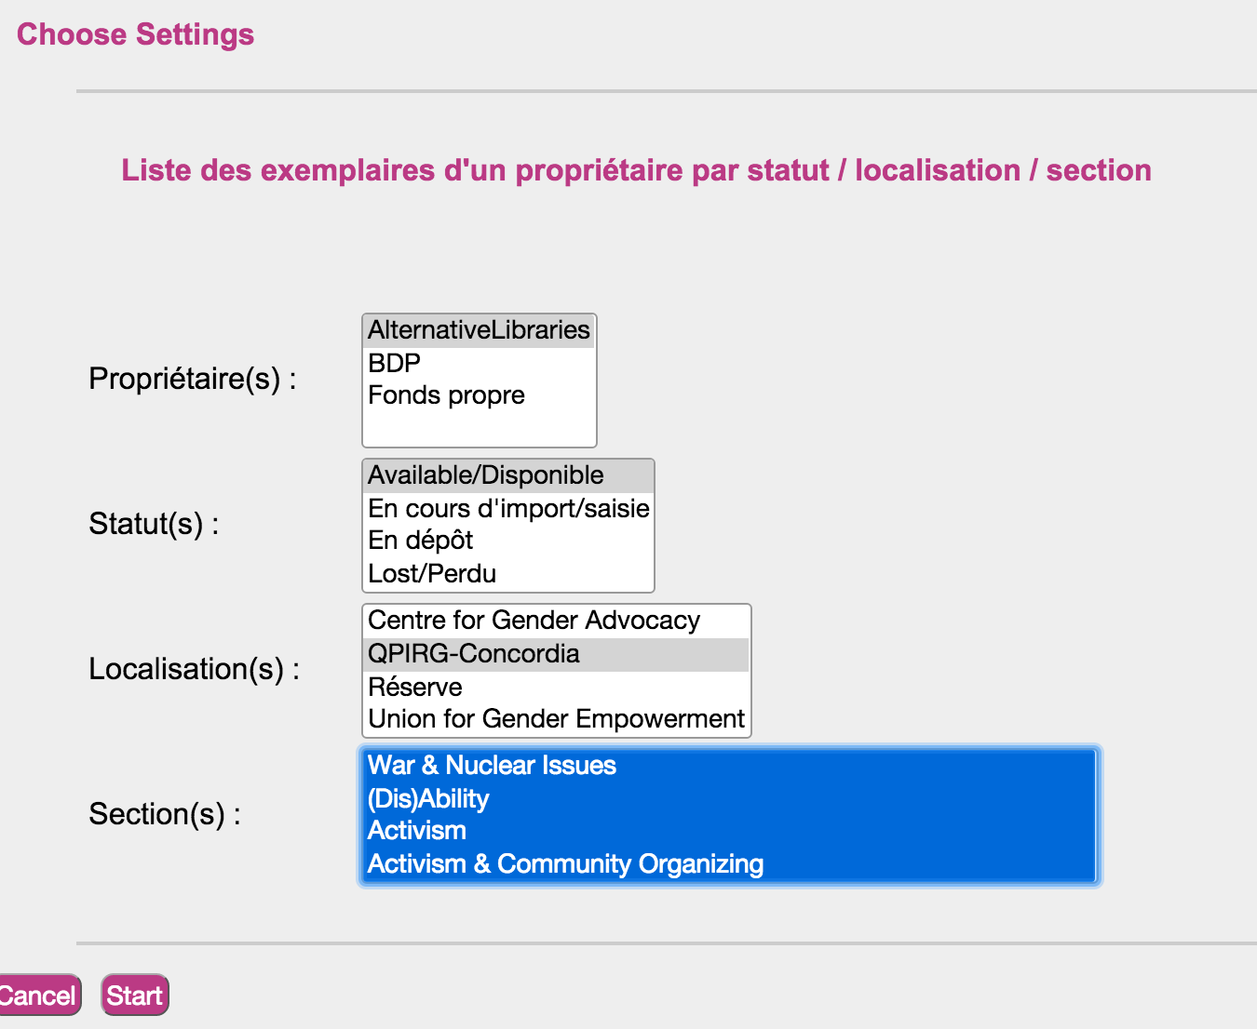

4) Scroll down to the bottom and click the spreadsheet icon

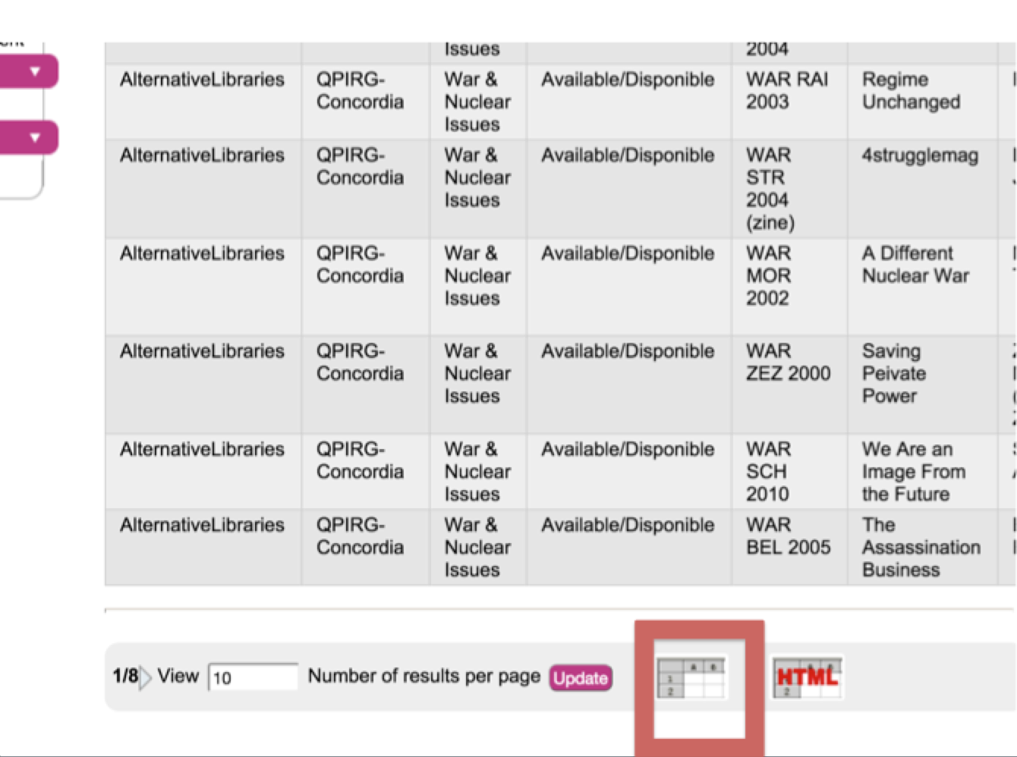

5) This should open an excel spreadsheet on which you can delete any info you don’t need.

